Ali Hasnain 2024088
Abdul Rehman 2024023
FEE A

Design and Implementation of a Programmable Automated Counting and Accumulation System Using Digital Logic
Abstract
This paper documents the design and simulation of a digital logic-based automated filling system. Unlike fixed-target counters, this system features a user-programmable batch size entered via a 4x4 keypad. The architecture integrates BCD-to-Binary conversion logic, synchronous counting, and an arithmetic accumulation loop to track total production. The system utilizes standard TTL and CMOS integrated circuits, including MM74C922 encoders, 74LS161 counters, and 74LS283 adders. The final design addresses critical timing constraints and signal integrity issues, providing a robust hardware solution for industrial pill or bottle counting applications.
I. Introduction
In pharmaceutical and beverage industries, packaging lines require precise control over batch sizes (e.g., 10 pills per bottle vs. 50 pills per bottle). While microcontrollers offer software flexibility, purely digital logic circuits provide higher speed, lower latency, and determinism.
The objective of this project was to develop a modular system that allows an operator to:
- Input a custom 2-digit batch size (00-99) using a keypad.
- Visually confirm the target batch size on 7-segment displays.
- Count items until the programmable target is reached.
- Automatically reset the batch count and add the batch size to a cumulative 8-bit total.
II. System Architecture
The system is divided into four primary functional blocks, as illustrated in the system block diagram.
A. User Input and Storage Subsystem
User input is captured via a 4x4 Matrix Keypad connected to an MM74C922 Encoder. This chip scans the keypad and outputs a 4-bit BCD (Binary Coded Decimal) value. The "Data Available" signal from the encoder triggers a 74HC273 Octal D-Flip Flop, which latches two successive key presses to store a 2-digit BCD target number (Tens and Units).
B. Display and Conversion Logic
The stored BCD target is fed into a 7447 BCD-to-7-Segment Decoder, driving two 7-segment displays to show the set batch size. Simultaneously, a combinational logic circuit utilizing Full Adders converts this 2-digit BCD value ($10 \times Tens + Units$) into an 8-bit pure Binary format. This conversion is necessary because standard binary counters and comparators operate in pure binary, not BCD.
C. Counting and Comparison Stage
The item counting is handled by two cascaded 74LS161 4-bit Synchronous Counters, forming an 8-bit counting stage. An 8-Bit Magnitude Comparator (formed by cascading two 74LS688 or 74LS85 chips) continuously compares the current counter value ($A$) with the user-defined binary target ($B$). When $A = B$, the comparator asserts an Active Low signal.
D. Accumulation Loop
To track the total number of items processed across all batches, an accumulation loop is employed. This stage uses 74LS283 Full Adders (corrected from the block diagram's label of 74LS85, which is a comparator) to sum the current stored total with the batch size. The result is stored in a second 74HC273 register, which drives a bank of 8 LEDs representing the cumulative total in binary.
III. Circuit Implementation
- Keypad Interface: The MM74C922 oscillator capacitors were tuned (1nF on OSC) to ensure reliable scanning without "double-typing" errors. The Data Available (DA) pin was used to clock the input registers, ensuring data is only saved when a key is fully pressed.
- Race Condition Management: A critical timing issue was identified where the batch counter would reset before the accumulator could save the new total. A delay chain consisting of 74LS04 inverters was implemented on the reset line. This ensures the "Save" clock pulse reaches the accumulator register before the reset pulse clears the counter.
- Reset Logic: The system features a "Combined Reset" architecture. A 74LS08 AND gate merges the automatic batch reset signal with a manual push-button signal and a Power-On Reset (RC circuit), ensuring the system initializes to zero upon startup.
IV. Component Specifications
Component | Function | Description
MM74C922 | Keypad Encoder | Handles key debouncing and matrix scanning.
74HC273 | 8-Bit Register | Used for storing the BCD target and the Cumulative Total.
74LS161 | 4-Bit Counter | Cascaded to create the 8-bit item counter.
74LS283 | 4-Bit Full Adder | Performs the arithmetic addition for the total ($Total = Total + Batch$).
74LS688 | 8-Bit Comparator | Compares real-time count to the target.
7447 | Decoder | Drives the 7-segment visual interface.

Block Diagram

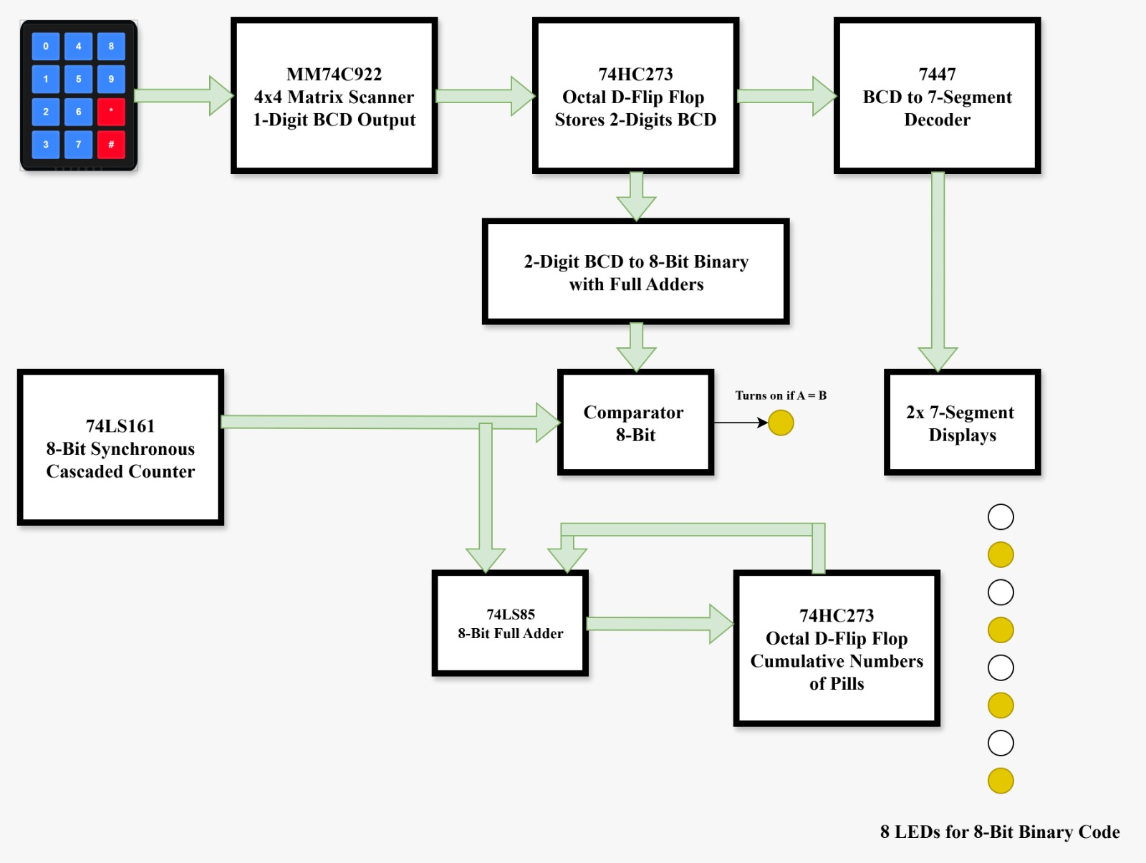

V. Simulation Results and Troubleshooting
The design was validated in Proteus ISIS simulation software.
- Input Stability: Initially, the keypad input was erratic. Adding a pull-down configuration and adjusting the scan frequency capacitor stabilized the BCD entry.
- Accumulator Accuracy: The accumulator initially showed incorrect sums due to floating inputs on the adder chips. Hard-wiring unused adder inputs to Ground resolved the error, resulting in precise addition (e.g., adding 10 to the total repeatedly).
- Reset Timing: The implementation of the NOT-gate delay chain successfully eliminated the race condition, allowing the system to run continuously without data loss.
VI. Conclusion
The implemented system successfully achieves the design goals of programmability and automation. By integrating a keypad input with a BCD-to-Binary conversion stage, the system offers superior flexibility compared to fixed-count circuits. The successful synchronization of the counting, comparison, and accumulation stages demonstrates the robustness of the digital logic design.
VII. References
[1] Fairchild Semiconductor, "MM74C922 16-Key Encoder Datasheet," 2001.
[2] Texas Instruments, "SN74LS161A Synchronous 4-Bit Binary Counter Datasheet," 1988.
[3] Texas Instruments, "SN74LS283 4-Bit Binary Full Adder Datasheet," 1988

